# Natural Language Processing with Sequence Models

**Course Objective:**

1. Train a neural network with GLoVe word embeddings to perform sentiment analysis of tweets,
2. Generate synthetic Shakespeare text using a Gated Recurrent Unit (GRU) language model,
3. Train a recurrent neural network to perform named entity recognition (NER) using LSTMs with linear layers, and
4. Use so-called ‘Siamese’ LSTM models to compare questions in a corpus and identify those that are worded differently but have the same meaning.

## Week – 1: Neural Networks for Sentiment Analysis

Learn about neural networks for deep learning, then build a sophisticated tweet classifier that places tweets into positive or negative sentiment categories, using a deep neural network.

Learning Objectives:

* Feature extraction
* Supervised machine learning
* Binary classification
* Text preprocessing
* ReLU
* Python classes
* Trax
* Neural networks

**Neural Network for Sentiment Analysis**

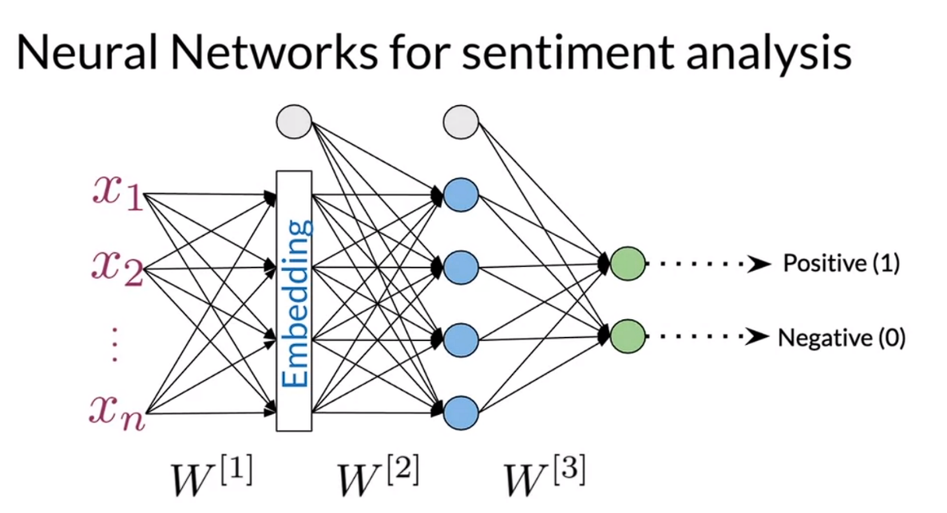

TRAX: Neural Network Library (Built on top of Tensorflow)

